PART 2 — Create AMI from EC2-1
Go to:
AWS Console → EC2 → Instances
Select EC2-1.
Then:
Actions → Image and templates → Create image
You will see:

Image name
Enter:
my-webserver-ami
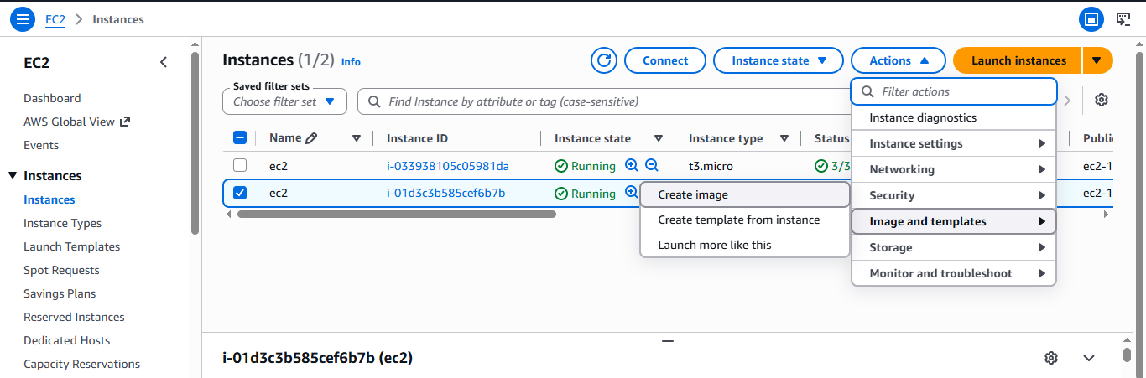

Image description
AMI for Auto Scaling web server
Leave the root volume settings as they are unless you specifically need to change them.
Click:
Create image
AWS will create your custom AMI.

PART 3 — Check AMI
Go to:
EC2 → AMIs
You should see:
my-webserver-ami
Status: Pending
Wait until:
Status: Available
Don't continue until it becomes Available.
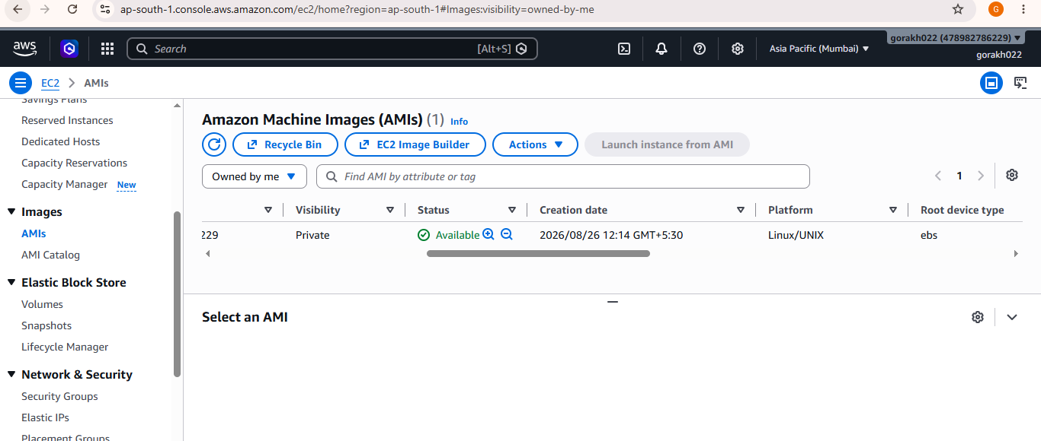

PART 4 — Create Launch Template In Auto Scaling

Go to autoscaling and create template

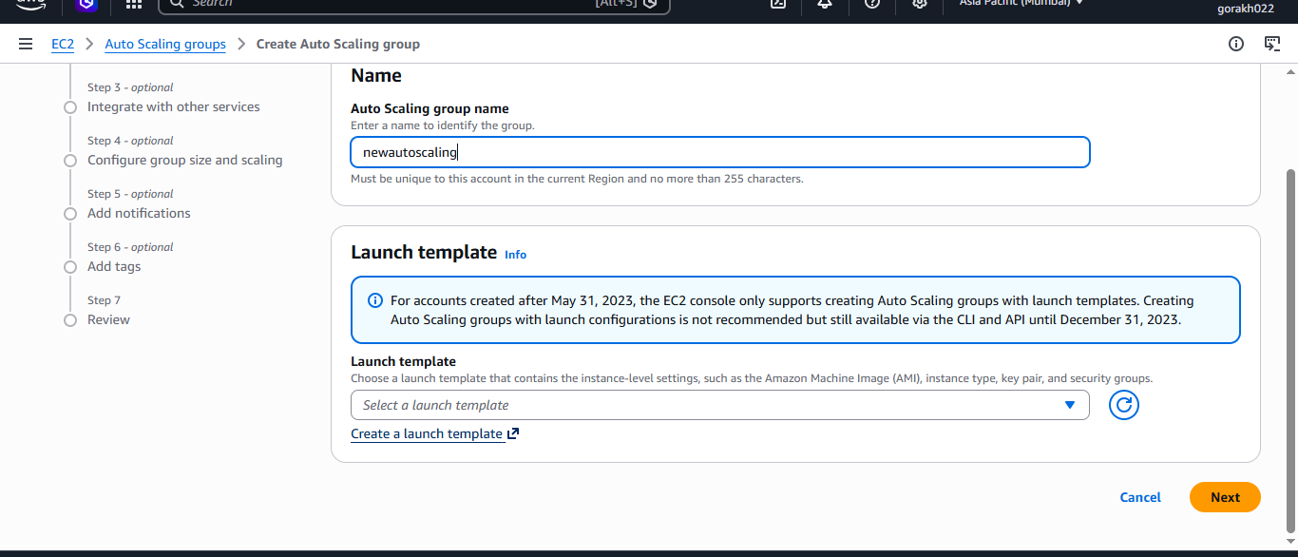

Application and OS Images
Choose:
My AMIs
Select:
my-webserver-ami
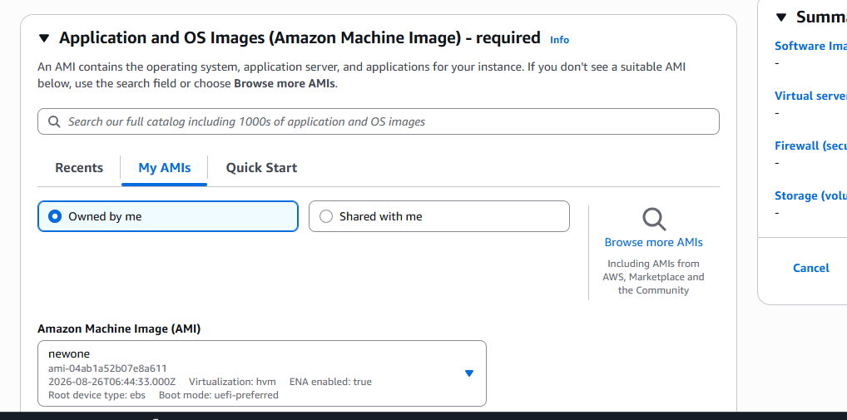

Instance type
Use the same instance type as your existing EC2.
For example:
t3.micro
or whatever you are currently using.
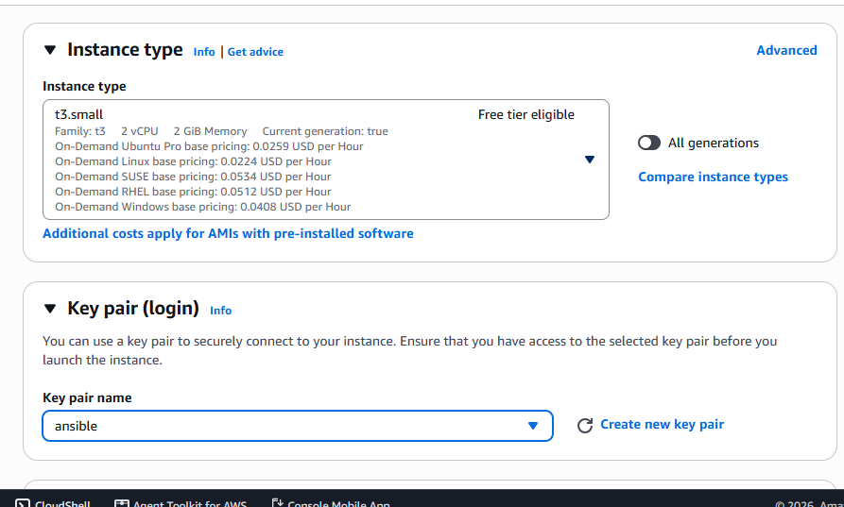

Key pair
Select the same key pair if you want SSH access to the automatically created instances.
For example:
my-key

Network settings

Security Group
Use the same security group that your existing web server uses.
It should allow:
HTTP TCP 80
from the appropriate source.
For SSH:
SSH TCP 22
preferably from your IP rather than 0.0.0.0/0.
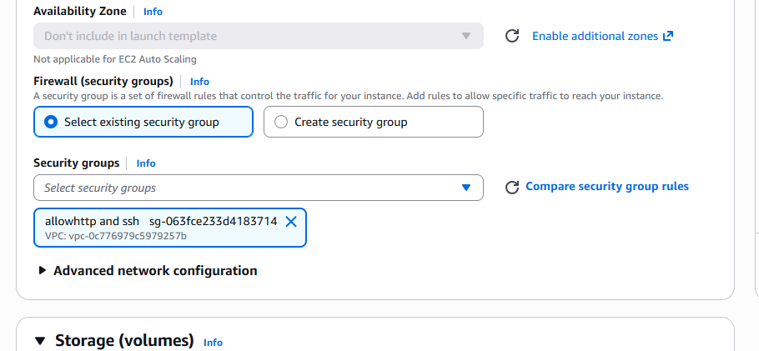

Don't hard-code a subnet
For the Auto Scaling Group, you'll select the subnets later. AWS specifically notes that ASG subnets are selected when configuring the group rather than relying on a subnet specified in the launch template.
Click:
Create launch template

PART 5 — Create Auto Scaling Group
Go to:
EC2 → Auto Scaling Groups
Click:
Create Auto Scaling group

Step 1 — Choose launch template
Name:
webserver-asg
Launch template:
webserver-launch-template
Version:
Latest
Click:
Next

PART 6 — Choose VPC and Subnets
Select the same VPC where your existing ALB/EC2 instances are located.
For example:
VPC: vpc-xxxxxxxx
Now select at least two subnets/AZs if available.
For example:
ap-south-1a
ap-south-1b
Select the subnets where you want the ASG instances to launch.
AWS recommends using the same Availability Zones covered by the load balancer for this type of setup.
Click:
Next

PART 7 — Attach Existing ALB
This is an important part.
Under:

Load balancing
Select:
Attach to an existing load balancer
Then choose:
Choose from your load balancer target groups
Select your existing Target Group.
For example:
my-web-target-group
You don't select the ALB itself here.
The relationship is:
ALB
↓
Target Group
↓
Auto Scaling Group
AWS automatically registers instances launched by the ASG into the selected target group.

PART 8 — Health Check
Under health checks, enable:
Turn on Elastic Load Balancing health checks
Set health check grace period, for example:
300 seconds
This gives the new EC2 enough time to start Apache and become healthy.
Click:
Next

PART 9 — Configure Group Size
Now you'll see:

Group size
Set:
Desired capacity = 2
Minimum capacity = 1
Maximum capacity = 3
So:
Minimum 1
Desired 2
Maximum 3

What this means
Normally:
2 instances
If load decreases:
2 → 1
If CPU goes above your scaling threshold:
2 → 3
But it will never go below:
1
and never above:
3
AWS requires the ASG configuration to specify desired, minimum and maximum capacity.
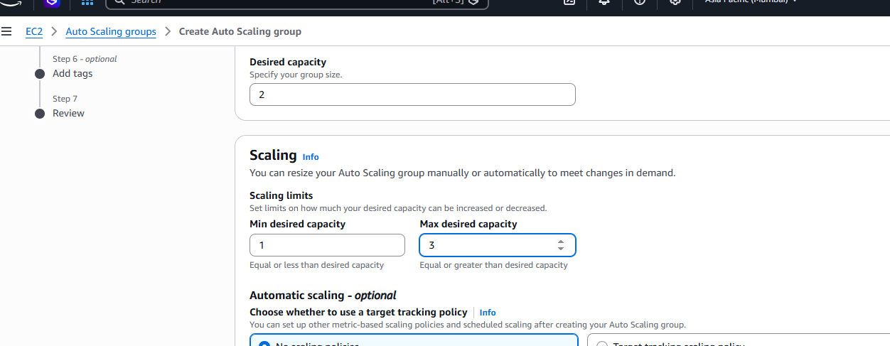

PART 10 — Create CPU Scaling Policy
In the Automatic scaling section, choose:
Target tracking scaling policy
For the metric, choose:
Average CPU utilization
Set:
Target value = 50
So your policy is approximately:
Average CPU > 50%
↓
ASG increases capacity
↓
New EC2 instance launched
Because your maximum is 3:
2 → 3
The important point is that target tracking isn't exactly a simple "if >50 then add exactly one" rule. AWS manages the desired capacity to maintain the target metric, subject to your min/max limits. For your lab, with desired 2 and max 3, the practical scale-out demonstration should be 2 → 3.
If you specifically want a step policy that says CPU > 50% → add exactly 1, you can configure a step scaling policy instead. For your first lab, I recommend target tracking because it is simpler.
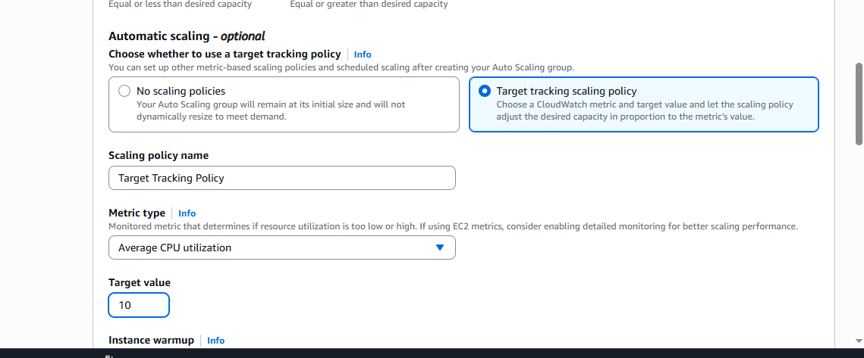

PART 11 — Finish ASG
Review:
Launch Template:
webserver-launch-template

VPC:
Your existing VPC

Subnets:
Your selected subnets

Target Group:
Existing ALB target group

Minimum:
1

Desired:
2

Maximum:
3

Scaling:
Average CPU = 50%
Click:
Create Auto Scaling group

PART 12 — Watch the ASG create EC2 instances
Go to:
EC2 → Instances
You should eventually see the new instances.
For example:
Existing:
EC2-1
EC2-2

New ASG:
i-aaaa
i-bbbb
The ASG-created instances should use your custom AMI.
You can verify:
EC2 → Instances → select instance
Check:
AMI ID
It should be your custom AMI.

PART 13 — Check Target Group
Go to:
EC2 → Target Groups
Select your existing target group.
Go to:
Targets
You should see your ASG instances.
For example:
Target Status

10.0.1.10 healthy
10.0.2.20 healthy
10.0.1.30 healthy
10.0.2.40 healthy
The exact number depends on what you have left registered.
The ASG automatically registers new instances into the target group you attached.

PART 14 — Important: Don't test CPU on the old EC2
You want to test the Auto Scaling instance.
Go to:
EC2 → Instances
Find an instance whose:
Managed by Auto Scaling Group
is your:
webserver-asg
SSH into that instance.
Example:
ssh -i my-key.pem ec2-user@PUBLIC-IP

PART 15 — Install stress on Amazon Linux 2023
If your ASG instance is Amazon Linux 2023, AWS includes both stress and stress-ng in the AL2023 repositories.
Run:
sudo dnf install stress -y
Check:
stress --version
Or install stress-ng:
sudo dnf install stress-ng -y

PART 16 — Start CPU Stress
First check the number of CPUs:
nproc
Suppose it returns:
2
Run:
stress --cpu 2 --timeout 600

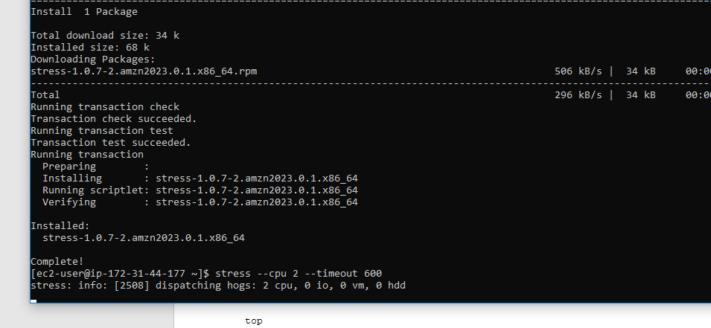
This means:
2 CPU workers
for 600 seconds
You can monitor CPU with:
top
You should see CPU utilization increase.
For stress-ng, you can also use:
stress-ng --cpu 2 --timeout 600
AWS documents stress-ng as a supported stress-testing package for Amazon Linux 2023.

PART 17 — Watch CloudWatch CPU
Go to:
EC2 → Instances
Select the stressed instance.
Go to:
Monitoring
Look at:
CPUUtilization
You should see something like:
CPU
100% | █████████
80% | █████████
60% | █████████████
50% |---------- Target 50%
30% |
+------------------------
Remember that Auto Scaling reacts based on the configured CloudWatch metric and evaluation periods, so the new instance may not appear immediately.

